

**CSE488: Big Data Analytics**

**[SPRING 2023]**

**Assignment**

**Online Assignment Lab 5**

**Submitted by:**

Student ID: Mujahidul Islam

Student Name: 2019-2-60-072

Code:

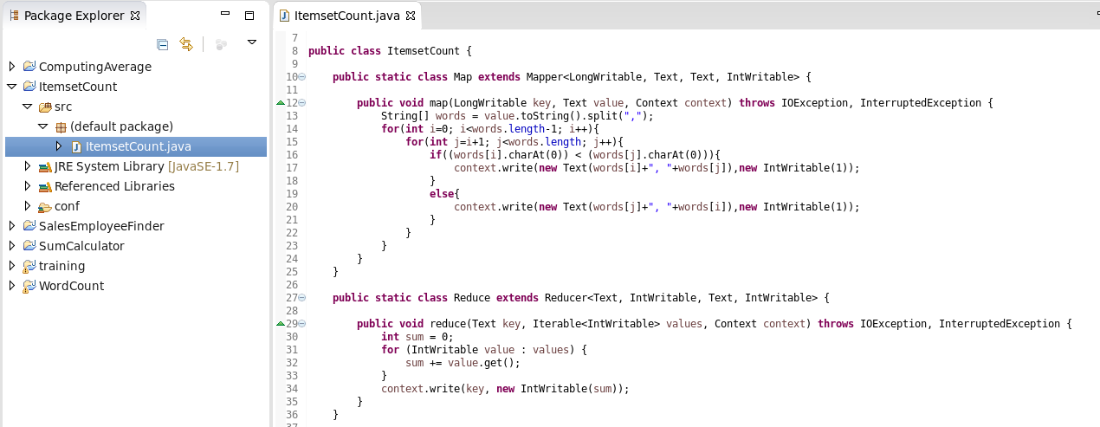

Input Files:

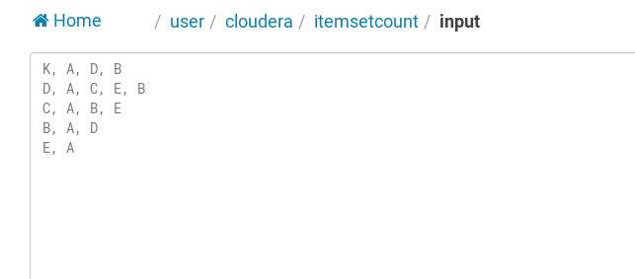

Executing Command Prompt:

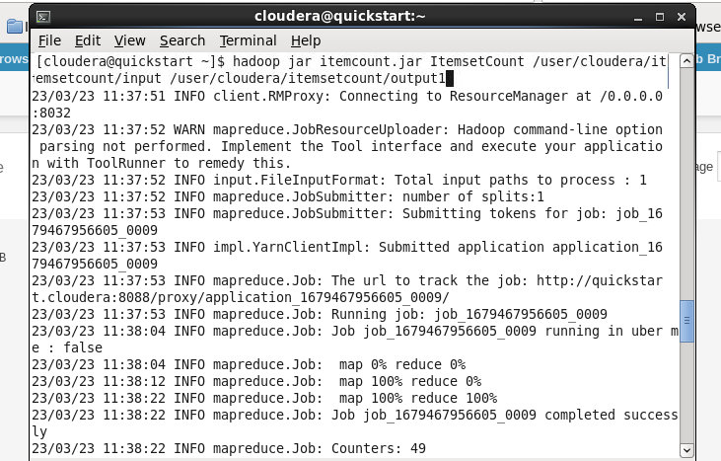

Output:

